Hazel W Lowe
- Memorial
- Photos
- Flowers
- Edit
- Share
Learn about upgrading this memorial...
Birth: 1922  Death: 1979  Family links:  Spouse:  James H Lowe (1920 - 2000)*  *Calculated relationship  Burial:  Danville Memorial Gardens  Danville  Danville City  Virginia, USA  Edit Virtual Cemetery info [?]  Created by: larry eanes  Record added: May 26, 2012  Find A Grave Memorial# 90745485 | 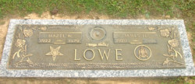  Added by: larry eanes  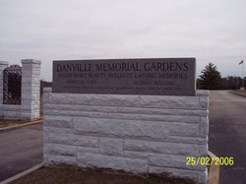  Cemetery Photo

